Reliability Analysis for Hot Spot Annotations in the MRDA Corpus

Britta Wrede
Elizabeth Shriberg

April 11, 2005

- Introduction

This document describes agreement on labeling of hot spots in the MRDA corpus. Because hot spots have variable length, have internal structure, and are labeled both for categorical type and hotness level, there are different ways to assess reliability, depending on which aspect a researcher is interested in. We were most interested in the issue of extent, since annotations often overlap but differ in exact extent. We present agreement results using a fuzzy extent approach, and comparing human annotation to randomly-generated annotations applied using true distribution characteristics.

- Procedure

The 75 meetings of the corpus were annotated for hot spots by two labelers who had also labeled the dialog acts in the corpus. These annotators were thus familiar with the meetings overall, as well as with many of the meeting participants. The hot spot labeling project began after the dialog act and adjacency pair labeling for the MRDA corpus had been completed. Due to very limited time and resources for this effort on hot spots, most of the data were labeled by only one or the other of the two annotators.

For assessment of reliability, we randomly selected 20 meetings, and from each meeting randomly selected an approximately 10-minute region of speech. The sample contains data from the three most frequent meeting types, i.e. the Bmr, Bro and Bed meetings. Each of the two labelers labeled each of these 20 chunks for hot spots. This labeling was done completely independently; labelers did not speak with each other about any of the data within these chunks. The labeling of the reliability chunks was done throughout the course of the overall labeling effort, which can be considered as beginning after the labeling document approach had been finalized, and thus when the annotation of the nonreliability chunks commenced. The overall effort for labeling the entire 75 meetings took about 4 months.

- Reliability measures

To evaluate inter-labeler reliability, we used a variety of metrics based on Cohen's Kappa. Kappa is a measure that normalises actual agreement by the agreement expected due to chance, according to the following formula:

Kappa = ( con_obs - con_exp ) / non_exp

where con_obs is the number of the observed concordant items, con_exp is the number of the expected concordant items and non_exp is the number of the expected non-concordant items. A Kappa value of 0 indicates a completely random distribution in two data sets, whereas a Kappa of 1 indicates perfect agreement.

We assessed agreement in a number of ways. Our main focus was agreement on the binary distinction ’hot spot’ versus ’no hot spot'. Since hot spots themselves have durations that can overlap, we performed this analysis using utterances as units. Every utterance label assigned by rater A was compared to the label of the corresponding utterance given by rater B, and vice versa.

- Hot spot growing

Because hot spots usually contain multiple utterances in sequence, it is not meaningful to use an utterance-based metric of agreement in which utterances are treated independently from other utterances. To address this issue, we chose the following approach. We assigned random labels to the data, drawing from a distribution reflecting the overall frequency and length of hot spots observed from the hand-annotated data, but distributing these labels randomly in terms of location. We created two such randomly generated versions of the labeled data. The expected number of concordant and non-concordant items was then computed by comparing these two random annotations with each other.

When comparing the two annotations, we noticed that while many annotations of hot spots overlapped, there were often differences in the annotation boundaries. Figure 1 displays two actual chunks from the hand annotations. The red and blue bars indicate annotated hot spots consisting of several utterances. As can be seen, the distribution of the hot spots in the two annotations is certainly not random. However, there are many utterance-level labels that do not agree, because the beginnings and endings of the hot spots do not always coincide across labelers.

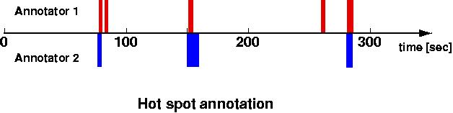
Figure 1: Plot of 2 hand annotation chuncks. The x-axis represents time in seconds. The top of the graph shows the sections of speech that were labeled as hot spots by annotator A, the lower half displays the hot spots as independently annotated by annotator B.

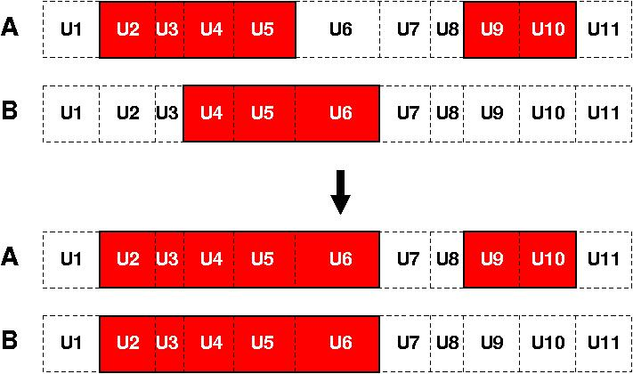
In order to take these considerations into account, we preprocessed the annotations before computing the Kappa value for the hot spot agreement by allowing overlapping hot spots to 'grow', such that if the two labelers overlapped in labeling a hot spot, the utterances inside the hotspots were assigned to a single larger hot spot region bounded by the maximal extent determined across the two labelers. This approach is illustrated in Figure 2.

Figure 2: Hot spot growing

Note that such an approach does not make much sense if hot spots are very frequent or located very close to each other. But they are in fact rather rare in the meeting corpus, and are separated by long regions without hot spots. Also, results are compared to chance results using the randomly placed labels described earlier, for whom the growing principle is also applied.

While for every overlapping hot spot the boundaries are synchronised, they remain untouched in the case of non-overlap. In Figure 2 this is the case for utterances U9 - U10 where a hot spot has been annotated only in annotation A but not in annotation B. When using this growing approach and normalising by the a-priori (expected) chance level, the overall agreement of utterances belonging to a hot spot versus not belonging to a hot spot is as high as .74. This approach can be interpreted as counting the overlapping and non-overlapping hot spots, and weighting them by their length. Note that this procedure has only been applied for computing the agreement on the hot spot annotation. For the computation of the agreement of the utterance labels such as hot spot begin (`a' or `n'), end (`c' or `e'), or involvement labels (`b' and `r') the original annotations were used.

Since this procedure simply increases the overall agreement of the two annotations when comparing hot spots, it has also to be applied to the random data that produces the expected agreement values. This way the gain in agreement caused by the growing technique is normalised by the random data where the same technique is applied.

3. Results

Results showed that this approach is very sensitive to even slight changes in the random data agreement. This is because the distribution of utterances belonging to a hot spot and those outside hot spots is highly skewed, with only 5.5% of the utterances belonging to a hot spot. We addressed the problem of the sensitivity to the random data by producing several sets of random data and computed Kappa values for the annotation data with each of the different chance normalisation factors. Figure 3 shows the distribution of the Kappa values for the hot spot vs non hot spot distinction (blue line) when using 100 pairs of different random normalisation data sets. The mean of this distribution (as shown in Table 1 in the column Chance Normalisation Values from Random Data) is Kappa = .67.

The same procedure for the computation of the Kappa values was applied to a number of distinctions. However, note that the growing technique was only applied to the computation of the agreement values for the hot spot vs non hot spot distinction. For all other distinctions the original annotation data was used. In order to assess the agreement for the different labels we analysed the following groups by comparing the label of each utterance in one annotation with the label of the corresponding utterance in the other annotation:

  - HS: an utterance belonging to a hot spot vs not belonging to a hot spot
  - Type: the type of a hot spot being amusement, clarification, agreement, disagreement, suggestion, other or no hot spot at all
  - Hotness: the hotness of a hot spot being one of the seven hotness degrees
  - Pros: an utterance being involved or spoken with raised voice or not involved
  - HS-Bound: an utterance being a starter or a finisher of a hot spot vs not being a starter or a finisher of a hot spot

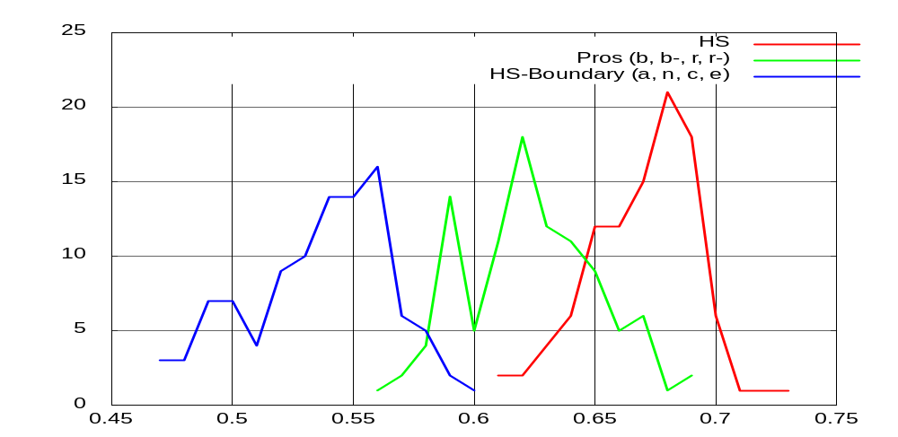
Figure 3: Histogram of Kappa values computed on the hand annotated data when using different random data sets for chance normalisation (N=100). Kappa values are shown for the distinctions HS (blue; leftmost), Pros (red; rightmost), and HS-Bound (green; middle). For more details see text below.

Table 1 summarises the agreement values for the distinction of these groups and subgroups. The colon indicates distinctions. Labels not separated by colons have been grouped together. In order to show the effect of the sequential nature of the data we report the Kappa values computed based on a-priori expectation values that do not take these effects into account, and the Kappa values based on expected values computed from random data. The latter values reflect the correctly normalised agreement.

Distinction | Chance NormalisationValues from
Distinction | Expected Values | Random Data
HS (hs : 0) | 0.74 | 0.67
Type (a : c : g : d : s : o : 0) | 0.40 | 0.67
Hotness (l- : l : w0 : w+ : h- : h0 : 0) | 0.41 | 0.42
Hotness (l- l : w- w0 w+ : h- h0 h+ : 0) | 0.49 | 0.49
Pros (b : b- : r : r- : 0) | 0.56 | 0.63
Pros (b b- : r r- : 0) | 0.58 | 0.62
HS-Bound (a : n : c : e : 0) | 0.40 | 0.54
HS-Beginning (a : n : 0) | 0.46 | 0.58
HS-Beginning (a n : 0) | 0.46 | 0.58
HS-End (c : e : 0) | 0.35 | 0.49
HS-End (c e : 0) | 0.42 | 0.51

Table 1: Kappa values of the hand annotated reliability data when using different normalisation values for chance normalisation.

In general, Kappa values are increased when using random data for chance normalisation. This is because the agreement values in the random data is even lower as the a-priori values would predict because in the random data the labels occur within a spot whereas the expected values would assume a completely random distribution of the labels across the data. For example, the label <b> only occurs within a hot spot leading to clusters of <b>. Thus, when comparing two random annotations where the labels are clustered in such a manner, it becomes even less likely that the same labels coincide. Only in the case of HS does a different pattern occur. It is not entirely clear why this is the case, but it may be due in part to the fact that there are slightly different prior probabilities for HS by the different annotators, which are not reflected in the random data.

In summary, agreement values on the reliability data indicate that the overall Kappa value for a region being part of a hot spot or not is .67. While not stellar, it is also not bad given that the annotation requires translating inherently continuous surface features of the speech into categorical labels, and normalising out for different speakers’ typical level of involvement. Agreement on involved utterances is also not too bad (Kappa = .63). On the other hand, with a Kappa of .54, the agreement on the hot spot boundaries is significantly lower. Thus, annotation of general hot spot location is more reliable than is annotation of hot spot edges.

A closer inspection of the effect of the growing technique for overlapping hot spots between two annotators shows as well that there is a difference in the agreement on the beginning and the ending of a hot spot. Figure 4 shows a histogram of the number of utterances that have been changed for each hot spot in order to make two independently labeled hot spots overlap completely. As can be seen in the vast majority of the cases no changes (0 utterances) needed to be performed. However, there is a difference between the beginning and the end of hot spots in that there is a clear trend indicating that more utterances have to be changed at the end of hot spots than at the beginning of hot spots.

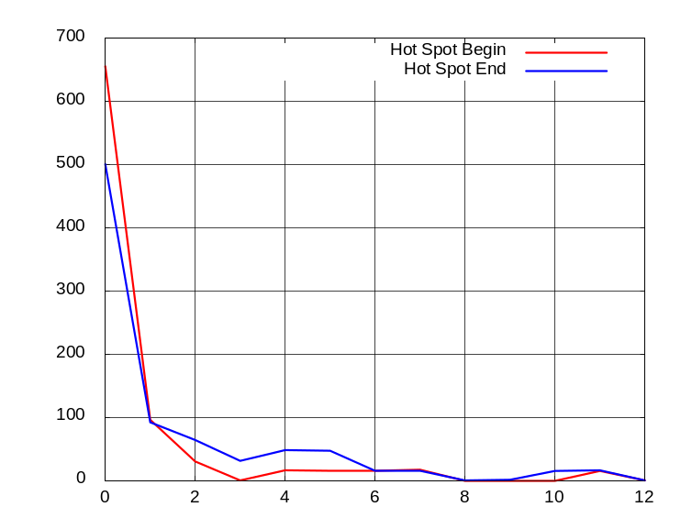

Figure 4: Histogram of number of utterances needed to fill the gap at the begin and end of corresponding hot spots in the two hand-annotation sets used for reliability.

Thus, hot spots have a relatively salient starting point, namely a trigger that causes the involvement, but the end is more difficult to determine. This is also reflected in the agreement values, which indicate a higher agreement on the starting labels (a, n) than on the ending labels (c, e) as shown in Table 1.

4. Summary

In summary: given the highly subjective nature of hot spot annotation, the inherent continuum involved in the task, and the difficulty of normalising out for speaker differences, we found that two annotators agreed reasonably well (Kappa = .67) in finding hot spot regions in the ICSI meeting data. We also found that agreement on involved utterances themselves is Kappa = .63. Results also indicate that finding the exact boundaries of hot spots is rather a difficult task, with the starting utterance being more reliably found (Kappa = .58) than the ending utterance (Kappa = .51).

